BibTeX:  
@INPROCEEDINGS{5336502,   
author={N. Petersen and D. Stricker},   
booktitle={2009 8th IEEE International Symposium on Mixed and Augmented Reality},   
title={Continuous natural user interface: Reducing the gap between real and digital world},   
year={2009},   
pages={23-26},   
keywords={augmented reality;gesture recognition;human computer interaction;human factors;3D interaction device;augmented reality;continuous natural user interface;ergonomic;real-digital world;user experience;virtual instance;Augmented reality;Computer graphics;Ergonomics;Industrial training;Keyboards;Mice;Multimedia systems;Switches;User interfaces;Virtual reality;Artificial, augmented, and virtual realities I.3.6 [COMPUTER GRAPHICS]: Methodology and Techniques;H.5.2 [INFORMATION INTERFACES AND PRESENTATION]: User Interfaces;Input devices and strategies H.5.1 [INFORMATION INTERFACES AND PRESENTATION]:Multimedia Information Systems;Interaction techniques},   
doi={10.1109/ISMAR.2009.5336502},   
month={Oct},}

**Bibliography**

Augmented reality in the field of human interaction has been a most attractive concept in the recent past. Integrating human interaction using gesture detection techniques having physical activity like grabbing, dragging, dropping etc. creates a user experience which is intuitive.

  The current article interests me since the authors propose a novel approach to an AR-based natural user interface, that goes one step further by enabling the contents of the interface to switch domains from a virtual instance in AR to a physical instance in the real-world. All instances stay associated and changes made to the physical instance will be reflected on the virtual one

  The paper has followed a unique approach for demonstrating the test case, by considering an exemplary industrial use case. Their contribution is the methodology for an intuitive interface called as continuous natural user interface (CNUI).

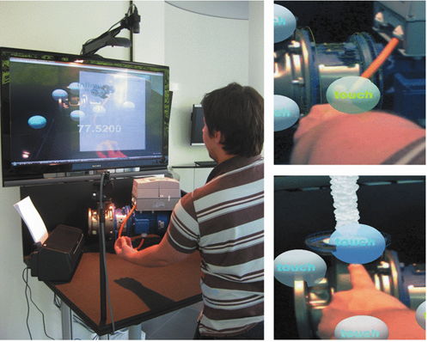

**References:**

* Anoto Group. Anoto digital pen. <http://www.anoto.com>.
* Apple. iPhone Multi-touch. <http://www.apple.com/iphone>
* UML Library guides
* IEEE Webpages
* H. Benko E. Ishak and S. Feiner. Cross-dimensional gestural interaction techniques for hybrid immersive environments. In Proc. VR '05 pages 209-216. IEEE March 2005.
* A. de los Reyes. Predicting the past. [http://www.webdirections.org/ resources/august-de-los-reyes-predicting-the-past](http://www.webdirections.org/resources/august-de-los-reyes-predicting-the-past).
* F. Guimbretière. Paper augmented digital documents. In Proc. UIST '03 pages 51-60 New York NY USA 2003. ACM.
* S. J. Henderson and S. Feiner. Opportunistic controls: leveraging natural affordances as tangible user interfaces for augmented reality. In Proc. VRST '08 pages 211-218 New York NY USA 2008.
* ACM. H. Ishii and B. Ullmer. Tangible bits: towards seamless interfaces between people bits and atoms. In Proc. CHI '97 pages 234-241 New York NY USA 1997. ACM.
* D. Holman R. Vertegaal M. Altosaar N. Troje and D. Johns. Paper windows: interaction techniques for digital paper. In Proc. CHI '05 pages 591-599 New York NY USA 2005. ACM.

"This is entirely my own work, except as disclosed in the documentation. I gave help to the following persons:   
None  
Signed Kiran C Shettar"